Project Design Phase-II Technology Stack (Architecture & Stack)

|  |  |
| --- | --- |
| Date | 17 May 2023 |
| Team ID | NM2023TMID11884 |
| Project Name | Al enabled car parking using OpenCV |

# Technical Architecture:

The Deliverable shall include the architectural diagram as below and the information as per the table1 & table 2

**Al enabled car parking using OpenCV:**

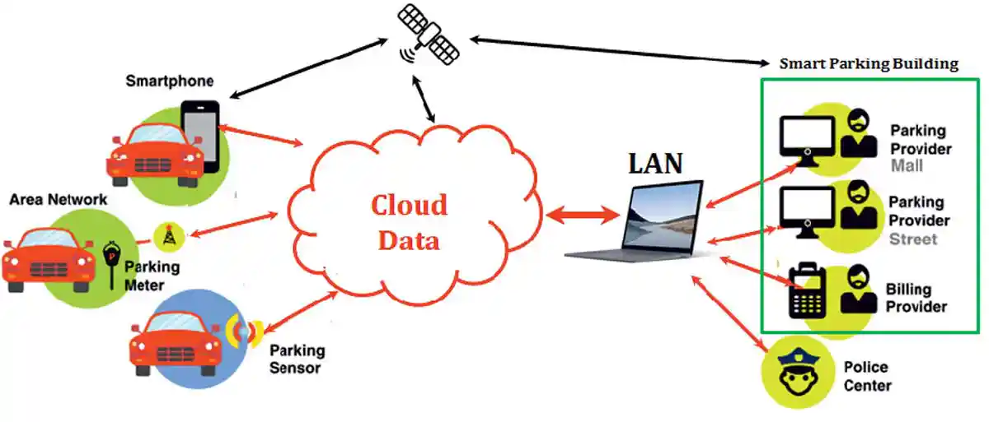

# Table-1 : Components & Technologies:

|  |  |  |  |
| --- | --- | --- | --- |
| **S.No** | **Component** | **Description** | **Technology** |
| 1. | User Interface | How user interacts with application e.g. Web UI | HTML, CSS, py-flask |
| 2. | Application Logic-1 | Logic for a process in the application | Java / Python |
| 3. | File Storage | File storage requirements | IBM Block Storage or Other Storage Service or Local Filesystem |
| 4. | External API-1 | Purpose of External API used in the application | IBM Weather API, etc. |
| 5. | Machine Learning Model | Purpose of Machine Learning Model | Object Recognition Model, etc. |
| 6. | Infrastructure (Server / Cloud) | Application Deployment on Local System | Local |

**Table-2: Application Characteristics:**

|  |  |  |  |
| --- | --- | --- | --- |
| **S.No** | **Characteristics** | **Description** | **Technology** |
| 1. | Open-Source Frameworks | Car Detection,OpenCV Parking Lot,Parking Detection,Smart Parking,OpenALPR | Technology of Opensource framework |
| 2. | Security Implementations | OpenCV provides a range of tools and techniques that can be used to implement security for AI- enabled car parking. By using a combination of object detection, face recognition, and license plate recognition techniques, you can ensure the safety of the parking lot and prevent any  unauthorized access. | Encryptions, IAM Controls, OWASP etc. |
| 3. | Scalable Architecture | AI-enabled car parking using OpenCV involves designing a system that can handle an increasing | Open CV Technology used |

|  |  |  |  |
| --- | --- | --- | --- |
| **S.No** | **Characteristics** | **Description** | **Technology** |
|  |  | number of cars without compromising on performance. |  |
| 4. | Availability | developing an AL enabled car parking system using OpenCV requires expertise in computer vision, image processing, and machine learning.  However, with the right expertise and resources, it is possible to develop a robust and reliable system that can accurately detect available parking spaces  in real-time. | Object detection Technology used |
| 5. | Performance | developing an AL-enabled car parking system using OpenCV requires expertise in computer vision, machine learning, and software development. However, with the right tools and knowledge, it is possible to create an efficient and  convenient car parking solution. | Intel processor used |